

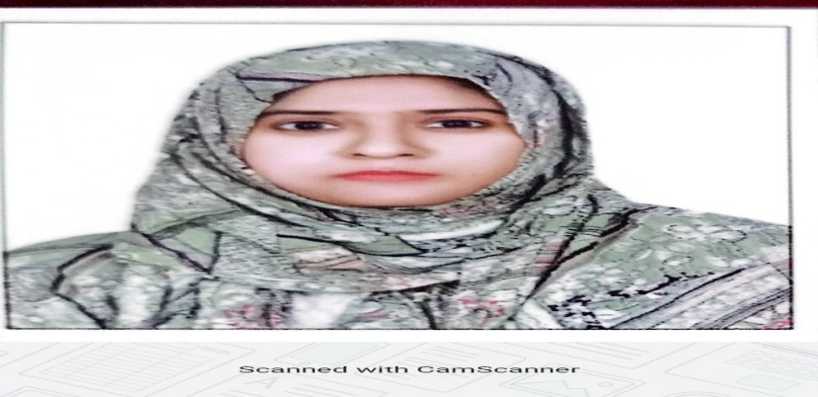

## Contact

[nusrathimtiyaz786@gmail.com](mailto:rose143willu@gmail.com) (+974) 33857003

Qatar

## Education

Perusing TEFL (UK Certification)

Master of Arts (English Lit)

B. Ed (Bachelor of Education)

Bachelors in Arts (English)

## Skills

Language Teaching Curriculum Development Classroom Management StudentEngagement Activity Based Learning Assessment Design Lesson Planning

Student-Centered Learning Technology Integration Host Competitions

Language

### English Hindi

Nusrath Banu

Educational Facilitator

## About Me

With over 15 years of teaching experience in the primary section at international schools in both Qatar and India, I am a dedicated and passionate educator committed to nurturing young minds. I strongly believe that learning should be inquiry-driven and activity-based, empowering every child to reach their optimum potential and become a lifelong learner.

My approach to teaching is rooted in creativity, engagement, and holistic development. I strive to create a joyful, inclusive, and stimulating classroom environment where students are encouraged to explore, question, and grow. Passionate about education

## Work Experience

**May 2015 – March 2025** **Birla Public School**

### Primary Teacher (CBSE Curriculum)

* Making lesson plans and presenting lessons in a comprehensive manner on spectrum smart boards and use visual /audio means to facilitate learning.
* Prepare worksheet on each topic taught.
* Making question, answer key, blue print and making revision worksheet.
* Prepare Documentation for school accreditation.
* Provide special worksheets and special classes for slow learners.
* Making weekly, monthly and yearly syllabus.
* Conducting various Co-curriculum activities.
* Attending CBSE workshop.

**Jul 1999**

**SSC-Silver Jubilee High School**

**Jun 2012**

**B. Ed (Osmania university)**

**Jun-2007**

**MA (Eng lit) – Vanitha College**

## Achievements

 Ten years - long term service.

 achieved 100% attendance in school for 3 years,

* Initiated project-based learning that led to community involvement
* Volunteered for extra classes, workshops, or after-school programs.

## Workshops Attended

 Workshops on D.S (Digital Learning Solutions)

* Workshop on Effective Lesson Plan.
* Magic School A1 by Extra Mile
* Inclusive Qatar Empowering Youth by KidZania Doha

 Workshop on Foundation in Early Childhood Development at the Lear novate Qatar

 Training Program on Best Teaching Practice by O.P Jindal Global.

 Training Program on Understanding and Meeting the Educational needs of children with Learning Disabilities, By the Compassionate Alliance.

 Training Creative Teaching Strategies by Mac Millan.

 Wellness session (Meditation & yoga in BPS parent partnership)

 Training on Reading Speed Session.

 Workshop on CPR

 Phonics, Practice and Assessment by Ms. Saswati  Training on Fire safety, First Aid, Safety & Security  "It’s all in the Brain- Cognitive skills, Problem Skills

and Attention"

 "Difference between Special Education Needs and  Psychological Counselling needs"

 Classroom Management and Differentiated Learning  "Handling Teens and Inclusivity"

# PERSONAL ATTRIBUTES

 Analytical Thinker

 Unwavering Professionalism  Intellectual Curiosity

 Resilience & Persistence

# ADDITIONAL INFLUENCE DOMAINS

 Documentation &amp; Compliance: Assisted in the documentation process for QNSA (Quality National Standards Assessment), ensuring compliance with educational standards.

 In-House Book Design: Designed in-house educational books tailored to the CBSE curriculum, enhancing learning materials for students.

 Event &amp; Activity Coordination: Coordinated school events, academic activities like Annual Day/Sports day/Class Assemblies/Special Events like Grand

 Parents Day, Teachers Day, Colour Days etc. and extracurricular programs, contributing to the overall development of students.

# Passport DETAILS

* Passport No. V9331361
* Date of issue - 3-5-2022
* Date of Expiry - 2-5-2032

**Personal Details**

* Name: Nusrath Banu
* Marital Status: Married
* State of Origin: Hyderabad
* Nationality: Indian
* Gender: Female
* Contact Number: 97433857003
* Contact Adress -11-4-404, Bazar guard Hyderabad

**Declaration**

I hereby declare that the above information is true to the best of my knowledge

And belief.

Place: Hyderabad

Date: 8.4.2025

References upon request