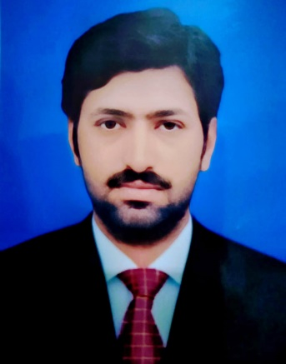

**Syed Muhammad Musa Kazim**

Lawyer | Legal Advocate | LLB

+92 300 9660551

[smkazim514@gmail.com](mailto:smkazim514@gmail.com)

District Khushab, Pakistan



**SKILLS**

* Legal Research
* Case Management
* Client Consultation
* Contract Drafting
* Courtroom Advocacy
* Legal Writing
* Dispute Resolution
* Negotiation Skills
* Document Review
* Legal Analysis
* Time Management
* Legal Compliance
* Case Preparation
* Public Speaking
* Conflict Resolution
* MS Office

**ABOUT ME**

A dedicated and skilled lawyer with experience in providing expert legal advice and representation in civil, criminal, and family law matters. Highly proficient in legal research, drafting documents, and courtroom advocacy. Strong communication and negotiation skills with a commitment to delivering successful outcomes for clients. Currently enrolled in the Punjab Bar Council, continuing to expand legal knowledge and expertise. Adept at managing complex cases and building strong client relationships.



**WORK EXPERIENCE**



**Lawyer**

**Chamber in Association with Raja Najabat Hussain Advocate**

**Sargodha, Pakistan**

**Duration: 3 Years**

* Managed legal cases from initial consultation to final judgment, ensuring timely and efficient proceedings.
* Advised clients on a wide range of legal issues, including property disputes, criminal cases, and family law matters.
* Represented clients in various courts, including sessions, district, and family courts, delivering persuasive arguments.
* Prepared and reviewed legal documents, including contracts, wills, affidavits, and statements of claim.
* Collaborated with senior advocates to strategize complex cases and improve case outcomes for clients.

**EDUCATION**

**Bachelor of Laws (LLB) (2019)**

Islamia University, Bahawalpur, Pakistan

Enrolled in Punjab Bar Council since September 2, 2021

**Master of Arts in Political Science (MA) (2017)**

University of Sargodha, Pakistan

**Bachelor of Arts (BA) (2014)**

University of Sargodha, Pakistan

**Intermediate (2012)**

Sargodha Board, Pakistan

**Matriculation (2006)**

Sargodha Board, Pakistan

**Legal Education and Training**

* **Enrolled in Punjab Bar Council**

Since September 2, 2021

* Continuing professional development through training and networking with experienced legal practitioners.



–

**STRENGTHS & CAPABILITIES**

* Strong analytical skills for assessing complex legal cases and issues.
* Excellent verbal and written communication skills in multiple languages.
* Highly organized, capable of managing multiple tasks simultaneously.
* Adept at maintaining client confidentiality and building trust.
* Skilled in negotiating settlements to achieve favorable outcomes.
* Proficient in legal document preparation and review processes.
* Quick to adapt to new legal technologies and tools.
* Proven ability to work well under high-pressure conditions.
* Strong attention to detail when reviewing legal documents and contracts.
* Committed to continuous professional development and legal education.



–

**PERSONAL INFO**

* **Gender**: Male
* **Nationality**: Pakistani
* **Date of Birth**: March 26, 1990

**LANGUAGES**

* English
* Urdu

**JOB EXPERIENCE**

**REFERENCES**

* References will be furnished on demand.

