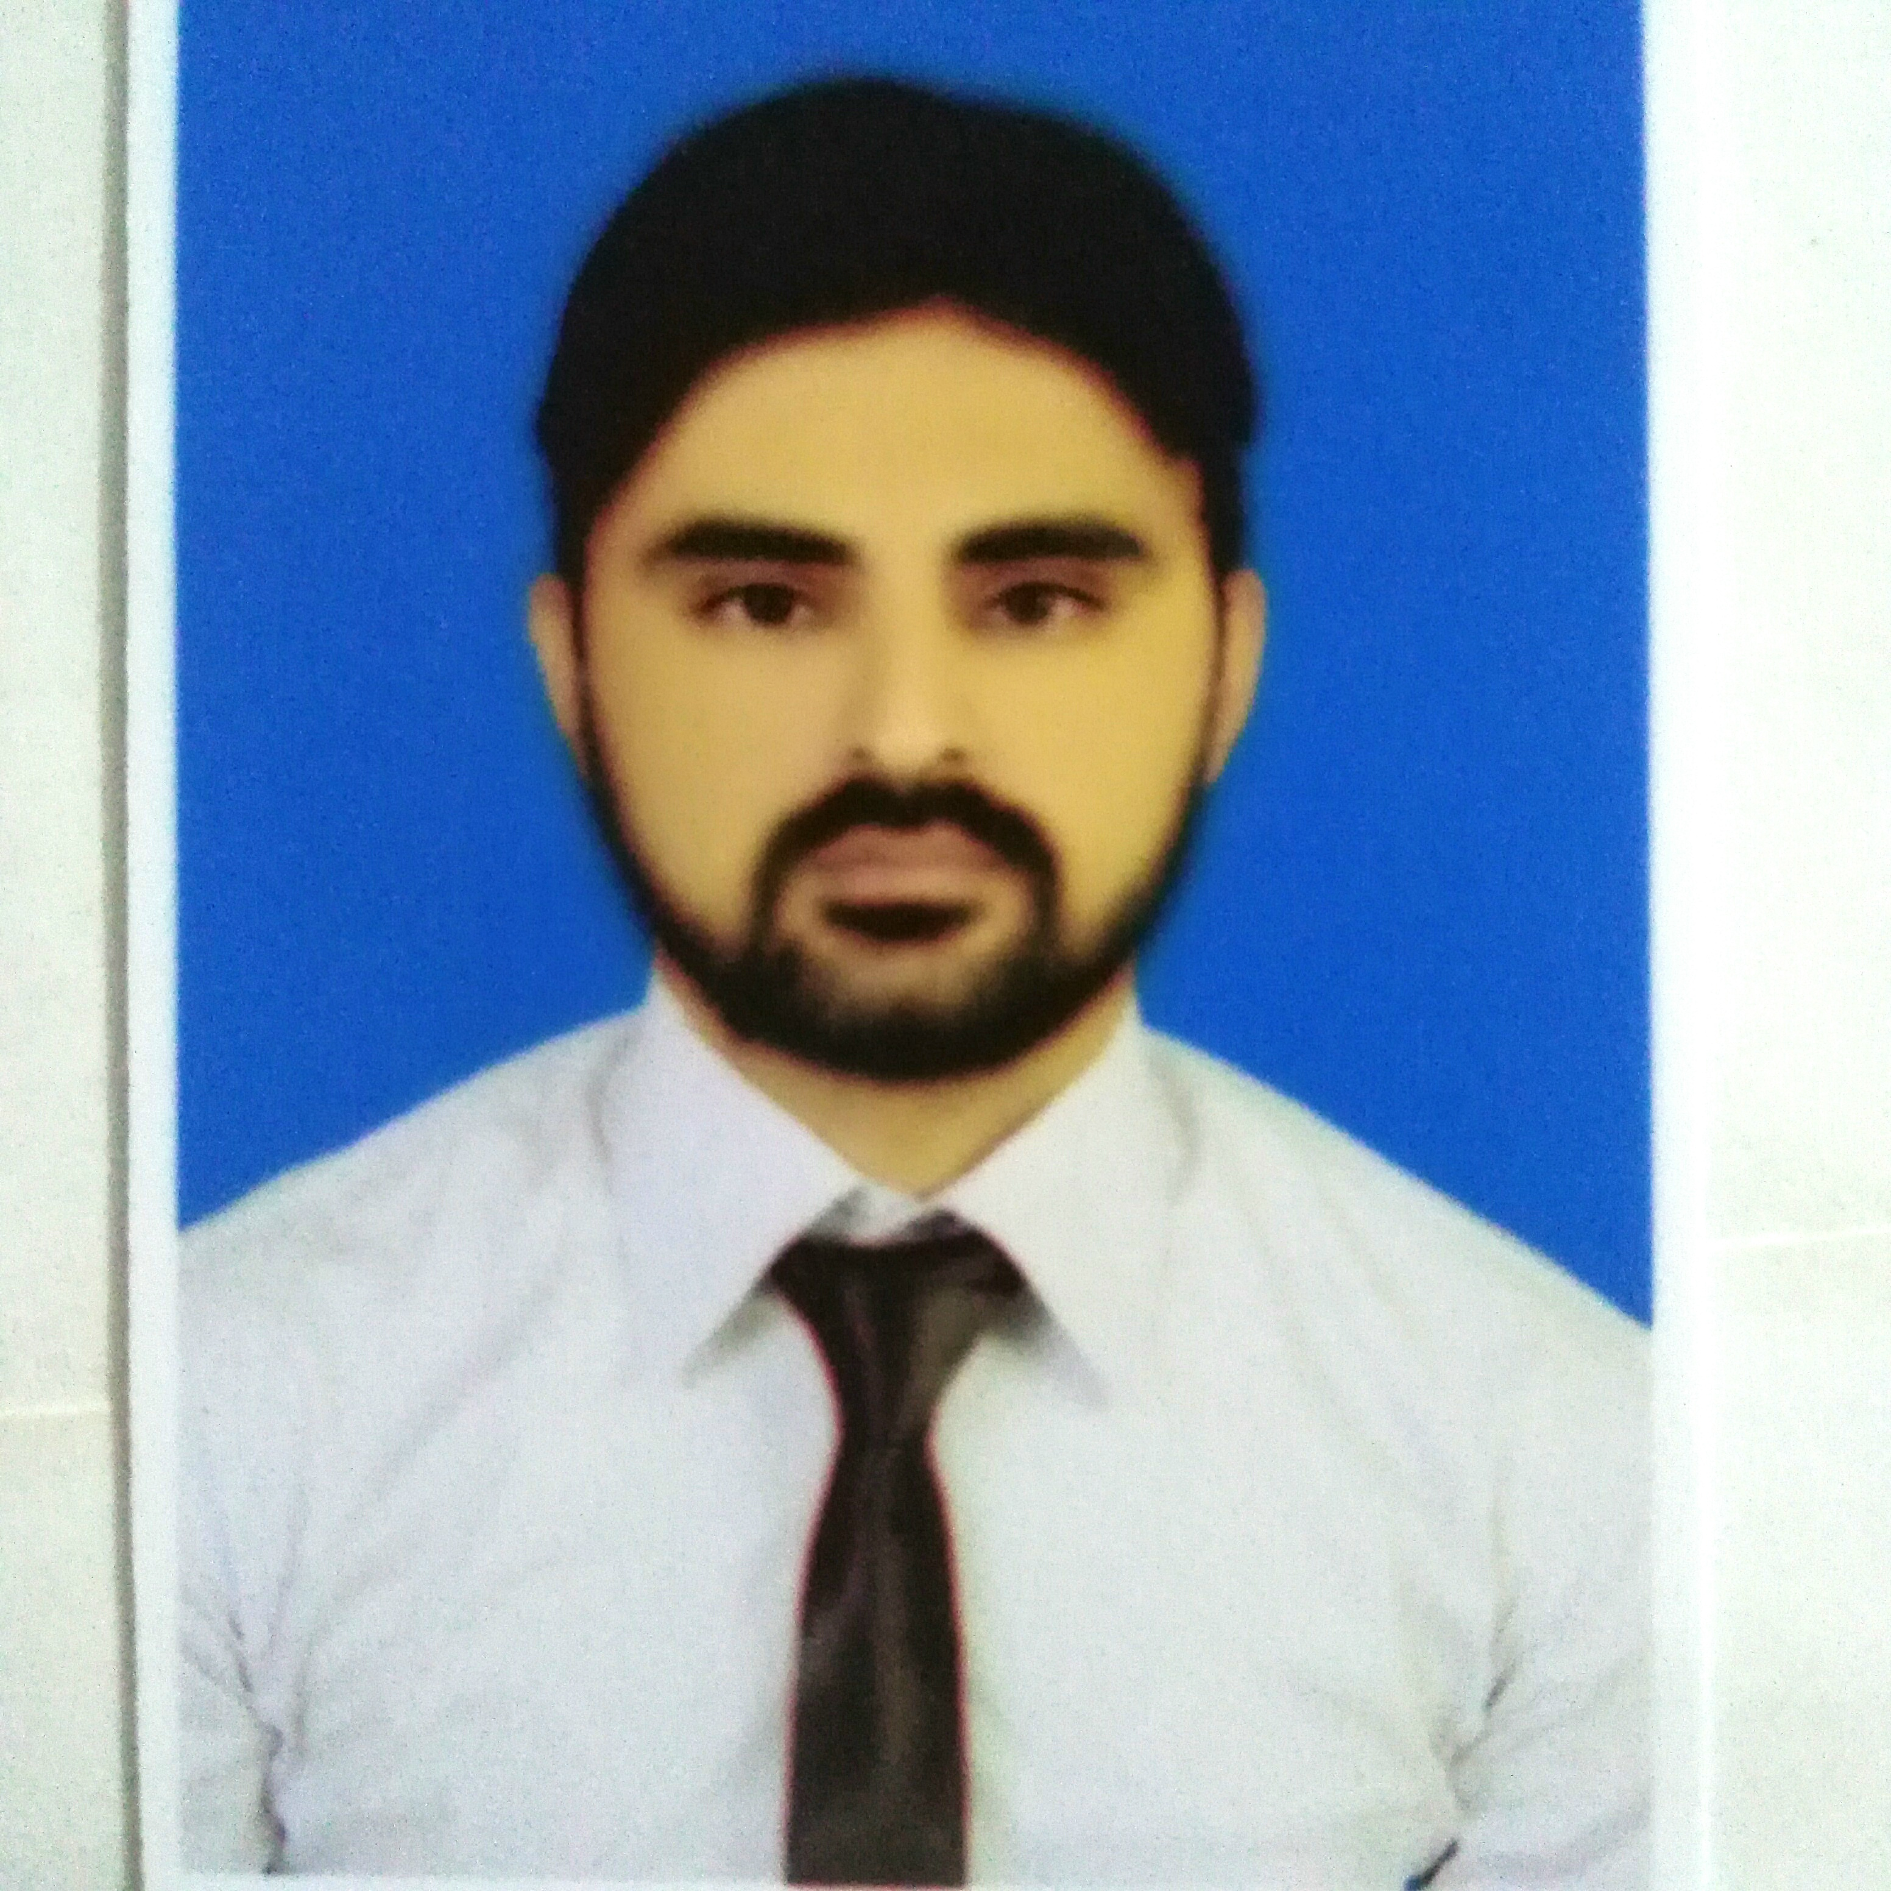

Postal Address: House#370/11--A..Bostan c colony,Qainche Amer Sidhu Lahore.Pakistan

Mobile: + 92-300-4086611

Email: aliazmat141088@gmail.com
ali_azmat99@yahoo.com

CAREER PROFILE

As a Sr Electrical & instrument (E & I)Engineer I am seeking a challenging career in system integration in a progressive learning environment with sound career development.

EDUCATION

- Preston Institute of Management Science and Technology 2011
B.Tech HONS (Electronics)
CGPA: 3.5

- Govt College Of Technology Raiwind Road Lhr 2007
Diploma of Associate Engineer (Electronics):
Percentile rank: 73%

- Qazi PilotHigh School Lhr 2004
Matriculation: S.S.C. Science
Percentile rank: 68%
PROFESSIONAL EXPERIENCE
Century Paper and Board Mills (Lakson Group of Companies) ( Oct 2007_ Present)

Worked as a Sr E & I Engineer in Electrical and Instrument Department (E&I). Have a great work experience on Siemens S7-200, S7-300, S7-400, ABB DCS system and Siemens drives & HMI. The 3 incomer lines of 11KV from our power house are step down to 3.3KV and 400V. A vast variety of proportional control valves, transmitters like pressure transmitters, level transmitters, consistency transmitters, temperature transmitters etc are installed in the field. Pneumatic and hydraulic actuators, solenoid valves, cylinders are used with various valves. Different proximity sensors are used for the interlocking of motors and valves. My job is to troubleshoot and install the different instruments, transmitters, drives, plc and designing the electrical drawings and panels.

RESPONSIBILTIES:
- Managing the complete shift jobs of Electrical and Instrument Department.
- Troubleshooting of ABB DCS.
- Troubleshooting and amendment of Siemens PLC, HMI, Touch panels, VFDs.
- Calibration and troubleshooting of all transmitters of Honeywell, Satron, Toshiba, ABB and etc.
- Calibration and troubleshooting of Proportional control valve.
- Working on Single phase and Three phase motors
- Working on Control and power circuits.
- Understanding Single phase and three phase Electrical Panels.
- Working on pneumatics and hydrauli system.
- Well versed with electrical diagrams.
- Direct on Line (DOL) Starters, Automatic star delta starters, Soft Starters.
- Planning and Execution shutdown jobs.
- Ability to meet targets and achievement.

INDUSTRIAL PROJECTS

During my association with Century Paper & Board Mills, I successfully completed the following projects
- BLEACH KRAFT PULP LINE:
Installation of flow transmitter (TOSHIBA) with the proportional control valve through Dcs at Stock Preparation Plant.

- PASABAN BOARD CUTTER:
Conversion of double blade cutter from single blade of a paper cutter machine import from Spain (PASABAN) with the co-ordination of Spanish engineer.

- AUTOMATION OF CONVEYOR
Automation of conveyor for loading paper piles and reels in Accelerator.

- UPGRADATION OF SIMOVERT TO SINAMICS DRIVES

Recently complete project on sinamics drives with korean staff.upgrade simovert master drives to sinamics drives.

CERTIFICATIONS

These include the designing of different projects using SIEMENS PLC, HMI and Drives and trouble shooting of these systems including both hardware and software.
- Siemens PLC LEVEL I ( 2012)
- Siemens PLC LEVEL II (2013)
- Simovert master drives ( 2014)
- Simatic wincc TIA portal (2015)
- Basic infrared Thermography. (2015)
- Vibration Analysis. (2016)

TRAININGS

Enterprise Resource Planning (ERP) and Industrial Hydraulics
SKILLS
- PLC Software:
Simatic manager.
- Drives Software:
1. Drive monitor.
2. Starter.
- HMI Software:
WinCC, WinCCflexible
- DCS Software:
Control Builder.
- Others:
- Window Installation ( Window xp ,window 7, Window 8,Window 10)
- MS Office..

PERSONAL DATA
- Nationality : Pakistani
- NIC No. : 35201-8658860-7
- Passport No. : DZ1858601
- Religion : Islam
- Marital Status : Married
- Date of Birth : October 14 , 1987
- Languages : English, Urdu and Punjabi

