2011

|

2014

2020

# SUMMARY

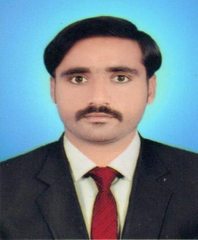To Utilize my Development And Abilities For My Demonstration Performance As an Agricultural Engineer, Where my Potential Will Put to Use for Stability of my Country in Agriculture field seeking Opportunity and Challenges for my Professional growth and Success



# EDUCATION

### Matriculation

### BISE Larkana

### Intermediate

### BISE Larkana

### Becholar Of Engineering B.E (Agri.)

Sindh Agriculture University Tandojam

# EXPERIENCE

### Loan Officer-General Loan

### From 01-12-2020 till to continue

MEER AHMED

## CONTACT INFO

Phone: 03103898128

Email: [meer.ahmed10804@gmail.com](mailto:meer.ahmed10804@gmail.com)

DOB: 07.04.1995

Gender: Male Nationality: Pakistani

Address: Village haji dost muhammad jakhrani uc sodhi kashmore

## SKILLS

MS/Office Internet Browsing

Friendly Cooperative And Confident

## LANGUAGES

EnglishUrdu Sindhi

Balochi

## HOBBIES

Communication Listening Writing Reading