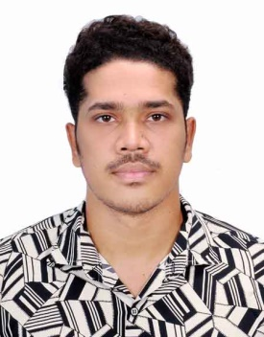

Md. Shoraf Bhuiyan
Rajarbagh police line, Dhaka Mobile No.01853956417
Email.ahmedshoraf.08@gmail.com

CAREER OBJECTIVE:
To build career in a growing organization, where I can get the opportunities to prove my abilities by accepting challenges, fulfilling the organizational goal and climb the career ladder through continuous learning and commitment.

ACADEMIC QUALIFICATION
- Studying B.SC (2018-19) in Department of Computer Science & Engineering(CSE) Studies at Sonargaon University(SU), Dhaka.
- Passed H.S.C (2019) with GPA 2.53 From Dhaka City International College, Dhaka.
- Passed S.S.C (2015) with GPA 4.61 From Rajarbagh Police Line High School, Dhaka.

OTHER QUALIFICATION
- Basic Knowledge In Computer

PERSONAL SKILL
- Team Spirit
- Accepting Challenges
- Good Oral Communication Skill
- Good Listening Skill
- Analytical Skill.
- Progressive and liberal mentality

EXPERIENCE
- I have 1 years of Experience in Website Designing
- I have 2 years Experience as Manager of lions Gym
- I have 1 years Experience as Dominos pizza Saudi Arabia

PERSONAL PROFILE
Name : Md. Shoraf Bhuiyan
Father’s Name: Md. Abdur Rouf Bhuiyan
Mother’s Name: Sufia Akther
Date of Birth: Jun 8,1999
Religion Islam
Language Bangla & English
Nationality Bangladeshi
Permanent Address Khishoreganj
Present Address A/2 Rajarbagh Police Line, Dhaka

DECLARATION
I solemnly declare that all the above information is correct to the best of my knowledge and belief.

Date: 01/05/2026

(Md. Shoraf Bhuiyan)

