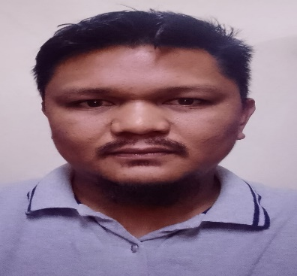
JAYAR V. VALENZUELA
Saudi Arabia: Al Qassim BuraidahPhil. Adds:
Bolinao Pangasinan Philippines
Mobile Saudi Arabia. +966 506970869
Mobile Phi. Contact: +63 9750293211
Email Add: valenzuelajayar463@gmail.com

CAREER OBJECTIVE
To obtain a position that will enable me to use my knowledge, background, and abilities to earn my success in my chosen career and contribute to the success of the Company.

SKILL AND KNOWLEGDE

- Saudi driver license holder.
- Microsoft excel and Microsoft word.
- Knowledge spare part of Mercedes bens truck, Howo Sino truck
- Knowledge spare part of Machine Hess RH 2000 RH 1500
- Knowledge of Moulds for concrete Products.
- Knowledge local part like Steel, cable, Rubber, Bearing etc.
- Spare part bard that I have Knowledge Lenze motor, SEW motor, FM sensor, Balluff Sensor, Hydac filters, parker hydraulic fitting.
- Knowledge how to export/import part of machine,
- Knowledge how to order international spare part.
- Knowledge (ERP) Enterprise Resource Planning SAJAYA SOFTWARE AND BAZZAR SOFTWARE

WORK EXPERIENCESS
COMPANY POSITION DATE COVERED
OPAL UNITED COMPANY/SAUDI Store manager July 2021- present

Duties Responsibilities:
- Manage store operational requirements by scheduling and assigning employees
- Prepare annual budget, schedule expenditure, analyze variances and initiate corrective actions
- Ensure availability of Spare part and products in store.
- Secure Spare part by implementing security systems and measures
- Maintain the stability and reputation of the store by complying with legal requirements
- Manage all controllable costs to keep operations profitable
- Manage stock levels and make key decisions about inventory control
- Update colleagues on business performance, new initiatives, and other pertinent issues
- Initiate changes to improve the business, e.g. revising opening hours to ensure the store can compete effectively.

EDUCATIONAL BACKGROUNDS
VOCATIONAL GRADUATE: Luzon college Science and technology 2011-2012
SECONDARY : Benigno V. Aldana national High School 2008-2009
PRIMARY : Pozzorubio central school 2000-2001

PERSONAL INFORMATIONS
Birthday: May 23, 1990
Birthplace: Pangasinan Philippine
Sex: Male
Civil Status: Married
Citizenship: Filipino
Religion: Catholic
Height: 5’9
Weight: 100 kgs

Contact person in case of emergency: Glenda Valenzuela – wife +63 975029321

I hereby affirmed that the above-written information is true and correct to the best of my knowledge.

JAYARV.VALENZUELA Signature of Applicant

