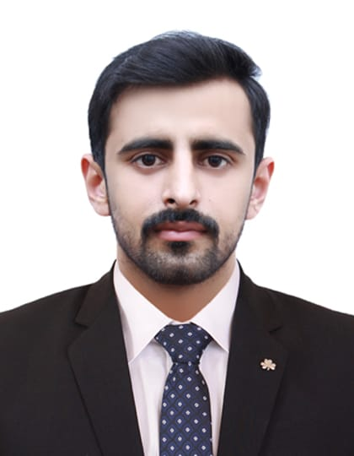Muhammad Shoaib

Cell #: +92-335-0171563

[**Shoaib.umar9999@gmail.com**](mailto:Shoaib.umar9999@gmail.com)House No. 269-C, Punjab University Employees Housing Society Town-II,

Raiwind Road, Lahore.



**Career Objective:**

To join a dynamic and progressive organization offering sample opportunities for diversified experience, and seeking a position which will allow for continued professional growth, offering an environment in which advancement is based on strength of individual contributions to the realization of organizational goals.



**Academic Qualification:**

**1- B.Sc. Continue (4 Semester Completed) Riphah International University**

|  |  |  |
| --- | --- | --- |
| **2- DAE-Electrical** | **2018** | **P.B.T.E. LAHORE** |
| **3- MATRIC** | **2015** | **B.I.S.E. SAHIWAL** |



**Professional Experience:**

1. From Aug-2023 to APR-2025 date, as a **Maintenance Supervisor MEP**

**Pakistan Aviators & Aviation (Pvt) Ltd**  PAAL Hangar Allama Iqbal International airport

1. From December-2022 to date, as **MEP Supervisor**

Safemed Ambulatory Care center, Faysal Town, Lahore

1. From July-2018 To Nov-2022, as **Assistant Engineer Electrical**

Nishat Hotels & Banquets Limited, Emporium Mall, Lahore

Routine Operation & Maintenance works on different type of electrical installation/equipment, mentioned below.

* Medium and Low voltage system
* Different types of DB’s, MCC Panels and switchgears
* Centrifugal Chillers, Absorption Chillers
* Air Handling Units and Fan Coil Units
* Specialist Lights and its controlling system
* Electric & Diesel Fire pump
* Different rating dry type and oil immersed transformers (25KVA to 2000KVA)
* 1350 KW Solar Installation
* Master Control System & Energy Monitoring System.
* Different type of water pumps
* Car Parking Guidance System
* Car Parking Ventilation System
* Air Compressors
* CCTV network
* Fire Alarm System
* Public address system
* Local Area Networking
* Cold Storages installations
* Smoke and Fire Fans installation
* Different rating Air conditions, Floor mounted, wall Mounted and Cassette Type
* 11 KV MV Panels, PIX & RK Type VCBs (Schneider Electric).
* 11KV/415V Dry Type Transformers Schneider Electric (630KVA to 2000KVA).
* LV Switchgears ACBs (Schneider Electric), MCC Panels, PDBs, LPDBs, UPSDBs, CBSDBs
* Performed Megger & Hi Pot Test of all equipment’s including Cables, Transformer, MV
* Use of different instruments, Earth resistance tester, process calibrator, multi-Meter, etc.
* De-hydration of transformers (1000KVA to 20/26MVA)
* Building Management System
* Fire Sprinkler System

I have experience on followings:

* Plans the execution of all electrical related works and coordinates the works to mechanical and civil groups.
* Preparation of Inspection reports, certificates, project progress reports, follow up punch list &
* Site correspondence with all contractors.
* Switchgears, LV switchgears, breakers & motors & prepare commissioning reports.
* Coordinates with Consultants & Contractors representatives for any site instructions and inspection of works.
* Submits site daily reports, inspection requests, estimates and all applicable monitoring reports on regular basis or as required.
* Review inspection reports and records of Quality Control carried out on completed and running Project activities.
* Review/Approval of engineering documents & drawings including Submittals, Tender drawings, Shop drawings, as built Drawings.
* Material & Installation Inspections MIR & RFWITs supervision & witness of site test &
* Checking the Workmanship and material Quality as per approved make and standard work for the Right quality and standard work
* Daily & Weekly work Progress Report Preparation and Keep the Record
* Cable size calculation, cable scheduling & its route selection, overhead or underground
* Estimates prepare and assign the resources such as manpower, materials, consumables, equipment, tools, etc., required for all electrical and related works prior to execution.
* Plans and analyses all possible construction methodologies and recommends the best options to the Project Manager for approval prior to execution at site.
* Preparation of Project Report for correct and Timely information for the Progress of work
* Project Final Documentation & Billing Works
* Prepare BOQs, estimating man-hour, material indenting & Bill verifications of all contractors.
* Supervised Laying Testing & Termination of underground 11KV LESCO MV Cables
* Inter department coordination with respect to routine operation & Maintenance.
* LESCO New Connection & maintenance related coordination.
* All Safety related procedures and activities with safety equipment
* Medium voltage switchgear (MV panel)
* Low voltage switchgear (LV panel)
* Dry type transformer (DTR)
* Uninterruptible Power Supply (UPS)
* Ring main unit (RMU)
* Earthing Network
* Lightening Arrestor
* Cooling Towers
* Air Handling Units (AHU)
* Fan Coil Units (FCU)
* Battery Chargers (24VDC, 110VDC)
* Fire Pumps
* Cable Tray & Cable Ladder
* Bus trunk Duct
* Distribution Boards
* Different Type of MCC
* Different Type of Lights



**Projects Completed (Supervised / Participated):**

* PAAL Hangar Allama Iqbal International airport
* Safemed Ambulatory Hospital, Faysal Town Lahore
* LV Switchgear Upgradation at NHPL, Lahore
* Nishat Hyundai Head Office PEB extension, Lahore
* Cattle Shed MEP Works, Jati Umrah Raiwind Road, Lahore
* Domestic Solar Projects (2KW to 30KW)
* Commercial Solar Projects (50KW to 150KW)
* Overhead Low Voltage Line, Jati Umrah Lahore
* Domestic and Commercial Wiring Installation Projects

* Computer Languages: MS Office.
* Operating System: MS Windows 98, XP, Vista, 7, 8, 8.1, 10
* Tools: AUTOCAD, Adobe Photoshop.



**Languages:**

* English
* Urdu
* Punjabi



**Reference:**

* Will be provided on demand.