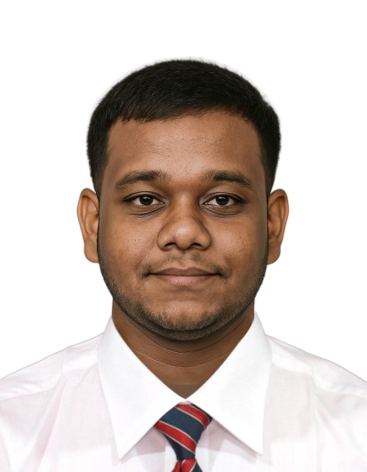**MUHAMMED MIDHLAJ M**  
Mangattuthodi House, Nechulli  
Thrikkalloor PO, Mannarkkad, Palakkad - 678593  
Phone: +91 9061474871  
Email: muhammedmidhlajmangattil@gmail.com  
Date of Birth: 26/01/2004  
**Nationality**: Indian  
**Marital Status**: Single

**Career Objective**

Aiming to secure a dynamic position that allows me to utilize my expertise in accounts management, vehicle operations, and customer service to drive organizational success and personal growth. Committed to delivering safe, efficient transportation solutions while upholding the highest standards of professionalism, reliability, and customer satisfaction.

**PROFESSIONAL SUMMARY**

A versatile, reliable, and skilled professional with hands-on experience in hotel operations, accounts management, and customer service. Known for my ability to adapt to fast-paced environments, maintain high standards of accuracy, and lead teams effectively. With a **valid light motor vehicle driving license** and proficiency in vehicle maintenance, I bring valuable skills to transportation and vehicle handling. Ready to contribute to a dynamic team in Saudi Arabia and grow professionally in a multicultural environment.

**WORK EXPERIENCE**

**Accounts Management & Billing Cashier**  
**MSR Fruits, Palakkad**  
*July 2024 – Present*

* Managed daily billing operations, ensuring timely and accurate processing of customer transactions.
* Handled accounts receivable and payable, contributing to the financial health of the business.
* Generated detailed financial reports, including balance sheets and cash flow statements, for management review.
* Enhanced customer service by resolving inquiries, addressing complaints, and processing refunds when necessary.
* Spearheaded the optimization of the billing system, which resulted in a 15% reduction in transaction processing time.

**Accounts Management & Billing Cashier**  
**TM Fruits, Mannarkkad**  
*Sep 2023 – Jul 2024*

* Maintained billing accuracy, processed cash and card transactions, and kept financial records organized.
* Balanced academic commitments alongside full-time work, demonstrating strong time management and multitasking skills.
* Produced monthly summaries of financial data for internal reviews and audits.
* Assisted in preparing tax reports, ensuring compliance with regulations.
* Improved workflow efficiency by developing a simple yet effective filing system for financial documents.

**Part-Time Restaurant In-Charge**  
**Chicky Wok, Mannarkkad**  
*2022 – 2023*

* Managed the day-to-day operations of the restaurant, ensuring timely service, quality food, and customer satisfaction.
* Led and trained a team of 5+ part-time staff, boosting productivity and team morale.
* Handled inventory control, reducing food waste by 10% through better stock management and forecasting.
* Implemented quality checks for food hygiene and safety, resulting in improved customer feedback and repeat business.
* Gained hands-on experience in resource management, supplier coordination, and restaurant financial operations.

**EDUCATION**

**Diploma in Hotel Management**  
*AHMS Cochin* – Completed: 2023

**ICSE - Integrated Corporate Solution Engineer**  
*ICS India, Mannarkkad* – Completed: 2024  
Focus: Computer Knowledge and Accounting

**12th Grade (HSSC)**  
*Victory Tutorial, Nellippuzha* – Completed: 2022

**10th Grade (SSLC)**  
*Sabari Higher Secondary School, Mannarkkad* – Completed: 2019

**TECHNICAL SKILLS**

* **Billing & Invoicing**: Expertise in managing accurate billing processes, invoicing, and cash handling.
* **Accounts Management**: Skilled in accounts payable/receivable, ledger management, and financial reporting.
* **Customer Service**: Excellent interpersonal skills to interact effectively with customers and resolve issues promptly.
* **Microsoft Office Suite**: Proficient in Word, Excel, PowerPoint, and other productivity software.
* **Basic Computer Operations**: Comfortable with operating systems, troubleshooting, and office management software.
* **Driving & Vehicle Management**: Proficient in vehicle maintenance, safety checks, and ensuring timely transportation.

**SOFT SKILLS**

* **Honesty & Integrity**: Strong ethical foundation, always maintaining honesty in financial transactions and customer interactions.
* **Time Management**: Effective in managing multiple tasks and prioritizing responsibilities.
* **Leadership & Teamwork**: Able to lead teams, train new staff, and collaborate with colleagues for common goals.
* **Communication**: Excellent verbal and written communication skills, enabling clear interactions with clients and colleagues.
* **Problem-Solving**: Quick to identify issues and implement practical solutions to resolve problems efficiently.

**ADDITIONAL DETAILS**

**Languages Known**:

* **Malayalam** (Fluent)
* **English** (Proficient)
* **Tamil** (Conversational)

**License**:

* **Indian Union Driving License**
* **Issued by**: Kerala Motor Vehicle Department
* **Date of Issue**: 12-10-2023
* **Valid for**: Light Motor Vehicle operations, compliant with international standards

**HOBBIES & INTERESTS**

* **Cooking**: Passion for preparing both traditional and modern dishes.
* **Listening to Music**: Relaxation and stress relief through music.
* **Traveling**: Exploring new places and learning about different cultures.
* **Reading**: Enjoying books related to personal development, business, and motivational topics.
* **Technology**: Constantly exploring new technological trends and learning new digital skills.
* **Driving**: Enthusiastic about driving and maintaining vehicles.