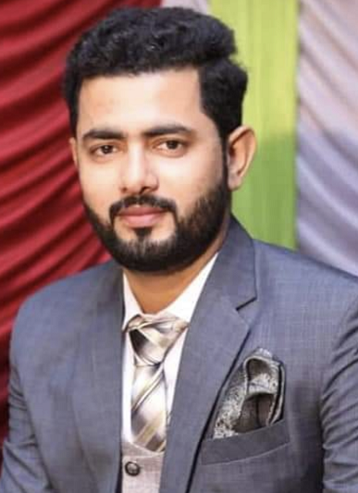  Extra-curricular activities:  - Travel  - Sports (badminton and football)  Computer Skills:  - SAP ,  - Oracle,  - Micro Soft Office,  REFERENCE:  Will be furnished on demand | AFTAB ALI  69-Makkah Madina Town Phase 1 Depalpur Road Okara.  +92-3474157366,+92-3099699059  PASSAPORT NO# UT1809821  Zicranaaftab043@gmail.com  OBJECTIVES:  I am eager to work with a growth-oriented organization and be part of a proactive program that will enable me to make use of my engineering skills, Experience, educational background so as to improve and polish my professional and inter-personal skill.  Work Experience:  Hi-Tech Blending (PVT) Ltd (4/2017 - Till Date)  Reputed with the name of ZIC Oil  Shift In-charge Production (Injection and Blow Molding).  - Production planning w.r.t. raw materials availability and production requirements.  - Implementation of Production SOP’s and improve procedures to minimize the production cost.  - Establish raw material continuity for smoothly production for mono and multilayers machines.  - Execution of in-process product inspection as per quality standards.  - Optimize the production process by looking at ways to reduce waste and increase efficiency.  - Continuously seek to improve operations and ensure compliance with operating standards to ensure brand integrity.  - Establish the production plane for products changing.  - Ensuring the understanding of production staff that how to improve the production by using relevant quality tools and trained them if required.  - Ensure all the working staff is working efficiently to get maximum output and efficiency.  - Set the production plans and procure raw material as per production plans.  ENGI PLASTIC (2/2016-3/2017)  Quality Control officer  - Quality Check on all the production activities as per production pans.  - Quality Check on raw material and utilities as per production plans.  - Define the quality control standards and ensure the product must meet those standards.  - Ensure safe and health work place to all the employees to maximize the efficiency.  - Work also on Recycling System  Material uses :Brooge (BD950) Brooge (MD 5868)  PROFESSIONAL QUALIFICATION:  Bachelors in Mechanical Technology CGPA: 3.49/4.0  National college of business and Economics, Lahore.  Diploma of Associate Engineering (Mechanical) 70%  Professional trainings  - Machine Safety, 5S Lean Management - Technical Skills ( December - 2021 )  - Quality Mindset to Zero Defects - Technical Skills ( February - 2022 )  - Awareness Session on "Quality Assurance Level (I) - Technical Skills ( March - 2022 )  - HACCP Level 3 Training Course - Technical Skills ( August - 2022 )  - Machine Safety & Safe Work Practices - Technical Skills ( December - 2022 )  - Awareness Session on HALAAL, HARAAM, NAJAS & Personal Hygiene - Technical Skills  PERSONAL INFORMATION:  Father Name Ghulam Ali  Date of Birth 21-03-1992.  Mobile Number 03474157366 , 03099699059  E-Mail address Zicranaaftab043@gmail.com  CNIC Number 35302-1822982-7  Permanent Address 69-Makkah Madina Town Phase 1 Depalpur Road Okara.  REFERENCE:  REFERENCE:  Will be furnished on demand

