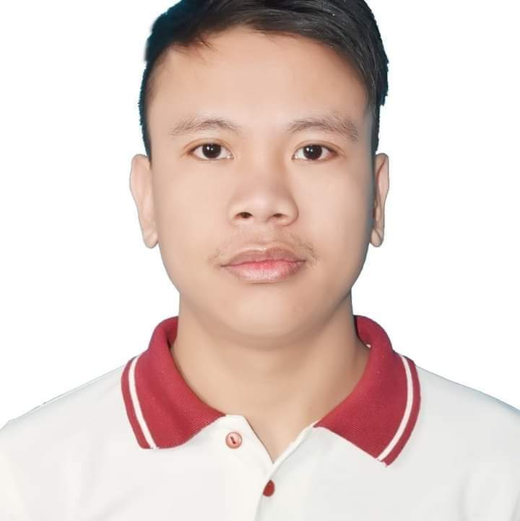**ALBERT RECREO RUBILLOS**

09944337875

(053)3006199

[albeetllos@gmail.com](mailto:albeetllos@gmail.com)

Purok 2, Dikeside Street,

Eastern Poblacion,

Hilongos, Leyte

6524

**Objective**

Evolving to the reality with high prosperity will commend in the condition sustaining to the most of recommendations from the core factors of success. Development with sincerity provides great of value.

**Profile**

Date of Birth: January 28, 1991

Place of Birth: Hilongos, Leyte

Sex: Male

Citizine: Filipino

Religion: Catholic

Father: Bienvinido T. Rubillos

Mother: Milagros R. Rubillos

**Skills and Attributes**

Food and Beverages skilled.

Basic knowledge to Computer Hardware and Computer Software.

Basic knowledge in Graphics designing.

Basic knowledge in Video Editing.

Basic Knowledge in HTML and Web Developing.

Minimum Data encoder.

Microsoft, Excel and PowerPoint proficient.

Good in English Communication skills written and oral.

Volleyball Player.

**Recognitions**

12-20-2020 Oath taking as Newly Elected SSC President. MLG College of Learning Inc.

11-10-2020 Participation of Supreme Student Council Election. MLG College of Learning Inc.

11-15-2017 Crew Trainer Class Development. Reza Foods Services ltd. Co.

01-01-2017 Most Improved Trainee. Reza Foods Services ltd. Co.

01-01-2017 Best in Service. Reza Foods Services ltd. Co.

12-25-2016 All Star super crew Competition. Reza Foods Services ltd. Co.

12-06-2016 Crew Development Class. Reza Foods Services ltd. Co.

**Work History**

06-10-2023 – up to present. Technical Support. TTEC PH. 11th fl eblcok 2 Bldg. IT Park,

Lahug Cebu

11-8-2021 – 04-15-2024 Advisor 1, Technical Support Concentrix CVG PH. i2 Bldg. IT Park, Lahug,

Cebu

12-10-2020-01-30-2021 Part time Head Quarter Staff kompra.store, Barangay Zaragoza,

Matalom, Leyte.

12-01-2017-04-13-2019 Swing/Shift Manager McDonald’s KSA, P.O. Box 20968 Jeddah

21465 Kingdom of Saudi Arabia.

04-01-2017-11-30-2017 Crew Trainer McDonald’s KSA, P.O. Box 20968 Jeddah

21465 Kingdom of Saudi Arabia.

06-12-2016-03-30-2017 Service Crew McDonald’s KSA, P.O. Box 20968 Jeddah

21465 Kingdom of Saudi Arabia.

06-25-2015-03-30-2016 Service Crew Zagu Foods Corporation, Janjelato

Foodcart, 51 Palawan Street, Marina

Baytown Subd. Tambo, Paranaque City.

**Education History**

2019 Bachelor of Science in Information Technology MLG College of Learning Inc.

Barangay Atabay, Hilongos, Leyte.

2015 Computer Hardware Servicing NCll MLG College of Learning Inc.

Barangay Atabay, Hilongos, Leyte.

2011 High School Imus National High School

Imus City Cavite.

2005 Elementary Hilongos South Central School

Hilongos, Leyte.

**Seminar**

05-24-2021 NTF-ELCAC &RTF-ELCAC Eastern Visayas Regional Conference on Peace & Development.

05-12-2021 National Student Orientation on going back to school through limited face to face.

05-10-2021 First National Higher Education Day Theme PADYAK Virtual Conference.

11-25-2020 Mental Wellness Talk Series: Stress Management.

02-15-2020 NSTP2 Community Service.

10-19-2019 NSTP1 First Aid Response.

**Character References**

Upon request.

I hereby declare and agree that a statement herein are true and complete to the best of my knowledge.

**Albert R. Rubillos**

Applicant