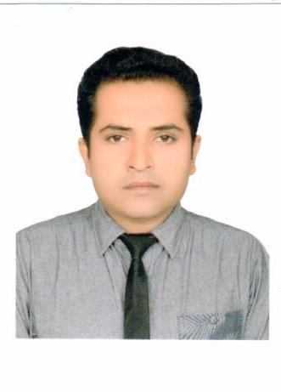
ALI HAIDER
Chak No. 149/E.B Arifwala.
Distt. Pakpattan.
Contact: 0311-6509892,03006956335

OBJECTIVE:

Seeking a position in well established organization where I could utilize my abilities and knowledge for the betterment of Bank.

Personal Information

Father’s Name: ALLAH DITTA
Date of Birth: 28-08-1989
C.N.I.C 36401-5797171-5
Domicile: Pakpattan (Punjab)
Nationality: Pakistan
Marital Status: Married
Religion: Islam

QUALIFICATIONS:

Experience:
Matric | 2005 | 2nd | BISE MULTAN
Inter | 2007 | 2nd | BISE MULTAN
B.A | 2010 | 2nd | BZU MULTAN
M.A(Phy Edu) | 2014 | 1st | GCUF
M.Sc (Economics) | 2012 | 2nd Division | B.Z.U Multan

- Worked as Universal Teller in Js Bank feb 2017 to Dec 2020.
- Working as CSO in bank Alfalah islamic Dec 2020 to May 2022
- Working as BBO in Habib Metro Bank Politan May 2022 to Feb 2024
- Working as CSM in JS Bank Feb 2024 to till now.

JOB DISCRIPTION:
1:Authorization
2: ATM handling
3:CLEARING
4:PRI PAYMENTS
5:PAY ORDER/CDR ISSUANCE
6:FUND TRANSFER
7:CHAQUE BOOK ISSUANCE
8:Account opening

LANGUAGES:
- URDU ENGLISH ( Read, Write, Speak )

