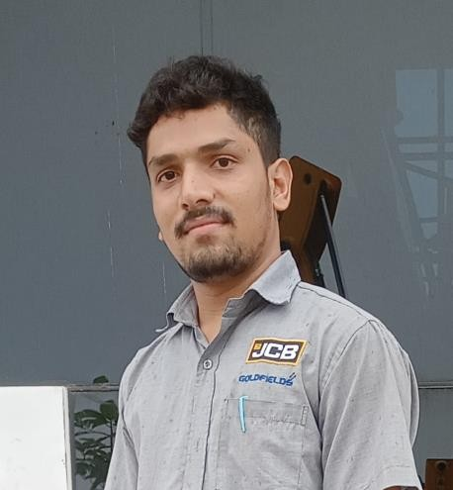

SHAIK ZAKRIYA HUSSAIN

JCB Service Engineer

CONTACT

PHONE:

+91 9059201638

EMAIL:

[shaikzakriyahussain4@gmail.co](mailto:shaikzakriyahussain4@gmail.com) [m](mailto:shaikzakriyahussain4@gmail.com)

[linkedin.com/in/shaik-zakriya-](https://www.linkedin.com/in/shaik-zakriya-hussain-502bb6249) [hussain-502bb6249](https://www.linkedin.com/in/shaik-zakriya-hussain-502bb6249)

Summary :

A JCB service engineer's responsibilities include:

* **Troubleshooting: Diagnosing and fixing problems with construction machines at customer sites**
* **Maintaining records: Keeping track of machine records and meeting MTTR targets**
* **Building customer relationships: Developing good relationships with customers and supporting dealer engineers**
* **Spare parts sales: Exploring opportunities to sell spare parts and perform workshop repairs**
* **Tracking competition: Monitoring the activities of competitors and reporting back to superiors**

Work Experience :

1. **. JCB SERVICE ENGINEER , JCB GOLDFIELDS**

July 2024 - Present

1. **. Sr.Us It Recruiter, Blue Verse Systems · November 2023 - June 2023**
2. **. US IT Recruiter , Acetechtalentz June 2023 - November 2023**

Education :

DIPLOMA

(Electrical and Electronics Engineering), GOLDEN VALLEY INTEGRATED CAMPUS

(GVIC Educational institution in Andhra Pradesh) ITI

(Electrical and Electronics Engineering)

SRI RANGANATHA ITI AUTONAGAR TIRUPATI SSC, ZPHS VALMIKIPURAM(URDU)