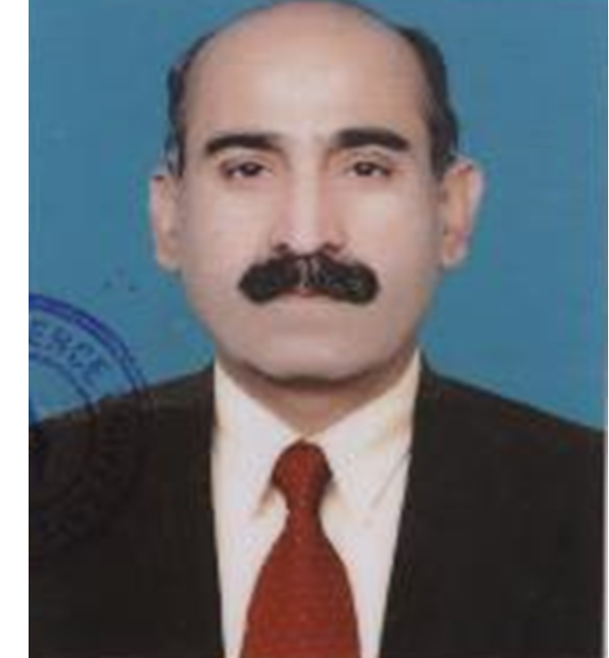­­­

**Oct 1987 to Dec 2001 – Clerk and Software Developer**

* Managed administrative tasks for the Clerk Admin Branch and Workshop & Establishment Branch.

**Oct 2002 to Mar 2008 – DBA and Front-End Developer**

* Developed and implemented the Human Resource Management Information System (HRMIS) for multiple centers including EME Centre (RW) Quetta and DSG Centre (RW) DI Khan & Engr Centre RW Risalpur.
* Developed web based solution which is Automated processes and enhanced user experience for the CSD account and inventory management system.
* Oversaw the full software development lifecycle, including planning, designing, coding, debugging, and testing. Utilized user feedback to implement system enhancements.
* Monitored application performance, identified improvement areas, and led code optimization as Project Manager / Team Leader of IDS.

**Apr 2008 to Dec 2013 – DBA and Front-End Developer, National Defence University (NDU), Islamabad**

* Developed and implemented comprehensive solutions for student attendance, fee management, and results tracking for over 2,500 students.

**Jan 2014 to Sep 2020 – Programmer and Team Lead, IDS Software House**

* Held dual roles as DBA, Team Lead, and Project Manager, conducting performance reviews to enhance team effectiveness.
* Spearheaded the development of an HRMIS with a biometric attendance system for 180 CSD shops, utilizing Oracle, PHP, Ajax, jQuery, and AngularJS.
* Created and implemented a Retail Management System (RMS) and business management tools for 180 CSD locations across Pakistan, leveraging Oracle for backend support and PHP, HTML5, Bootstrap, and JavaScript for frontend development.

**Sep 2020 to Sep 2025 – Office Assistant at FFH Lahore**

• **Served for five years as an Office Assistant to the Medical Superintendent at Fauji Foundation Hospital, Bedian Road, Lahore, independently managing all operations of the medical branch.**

**• Developed and implemented over 200 Standard Operating Procedures (SOPs) to secure the Punjab Healthcare Commission (PHC) license and ISO certification, successfully achieving both.**

**• Successfully completed Punjab DAG and PHC’s 180 key indicators for hospital licensing, managed the web portal data, and maintained the system independently for five years. Will be an asset for any hospital. My Main roll at FFH Lahore was Medical billing, Reimbursement, Monitoring and management and coordination of All department of hospital and head office under the direct supervision of Medical Superintendent**

**• Highly skilled in medical billing and transcription writing.**

**Hon N/Sub Clerk**

**Muhammad Yasin , Tk-III (Retd)**

**+92-313-7357993**

**Yasinarain68@gmail.com**

Page 1

# Highlights

* Accomplished Mega ERP for different organizations
* Great Communication and customer care service skills.
* Reliable and dedicated when working alone or as part of team.
* Committed job seeker with a history of meeting company needs with consistent and organized practices .
* Skilled in working under pressure and adopting to new situations and challenges to best enhance the organization output.

# Education

Graduate - 2016

# Certifications

OAC – MCS Rawalpindi

COC – MCS Rawalpindi

SCC – ASL Murree

17 x UNITAR Certifications from 2004-2006 , LIBERIA, UNO

**Proficiency**

**Oracle DBA &forms and Report Developer PHP, CSS, JS , Jquery and Angular JS**

**C# , VB and Dot Net, ASP & ASPX**

**PHP , JS, angular JS, HTML5, CSS-3 & Bootstrap all vers**

**Back End and Professional Front End Developer**

**Hardware Integration with Computer software, Like RFID Tags and Bio-metric**

­­­

**+92-313-7357993**

**Yasinarain68@gmailcom**

Page 2

* **Profile Summary as Front-end Software Developer**
* **Visual Creator. I excel in crafting visually captivating and intuitive websites and applications by leveraging UI/UX design principles to consistently exceed client expectations.**
* **Innovative Technologist. With expertise in Angular, Ajax, and PHP, I apply front-end development best practices to deliver cutting-edge, high-quality solutions tailored to client needs.**
* **Collaborative Developer. Proficient in HTML, CSS, JavaScript, and various front-end frameworks, I design dynamic and responsive interfaces that enhance user experience and engagement.**
* **Analytical Back-end Specialist. I hold expertise in C# and PL/SQL, PHP and Oracle forms and reports, creating efficient and secure systems to address complex client requirements.**
* **Freelancing Projects Completed**
* **Business Accounting Solutions for a client in Saudi Arabia through Upwork (Jan 2021 - Dec 2023).**
* **Online Restaurant and Hotel Management System developed for multiple Fiverr clients.**
* **University and School Management System for five schools in the USA, featuring biometric attendance and real-time data access, developed using MySQL, PHP, and C# (Jan 2017 - Mar 2017).**
* **Business Management and Accounting System for accountants of various businesses and factory owners in Saudi Arabia, completed as an Upwork project.**
* **Biometric Attendance & College Management System. Developed a comprehensive ERP solution featuring ZK Tech's biometric real-time attendance tracking integrated into a web-based platform. The system encompasses a complete management solution for staff, students, teachers, and parents, including modules for results, subjects, class timetables, student and parent feedback, library management, events, and more. It also supports detailed student and teacher profiles, performance tracking by subject, curriculum activities, and a notice board. This solution was built using PHP, MySQL, C#, HTML5, CSS3, and .NET Framework 4.5. I successfully delivered this project to clients from the USA, Saudi Arabia, Kuwait, Kenya, and Bangladesh via Upwork and Fiverr.**

Page 3

**Distinguished Awards**

* **Tamgha-e-Khidmat-III awarded by the President of Pakistan.**
* **CJCSC Commendation Card for outstanding performance at NDU Islamabad.**
* **COAS Commendation Card for exemplary performance and successful completion of HRMIS for EME Centre RW.**
* **Earned outstanding Grading in my all 23 x Annual Confidential Reports(ACRs)**
* **COAS Commendation for achieving 23 Outstanding ACRs.**
* **Cash Award of Rs. 300,000 from PA Dte GHQ Rawalpindi for securing first position in a Software Competition.**
* **Commendation Card and Cash Award from GOC 15 Div for exceptional performance in software development for tech inspections.**
* **Recommended for Acceleration Promotion as N/Sub by Lt Gen Muhammad Yousaf , President NDU and Lt Gen** Lt. Gen. Nasir Khan Janjua, Comd 12 Corps but can not be promoted due to non availability of Vacancy of Pb class.
* **Awarded Outstanding Grading in Appraisal Report while serving at FFH Lahore.**